**DIRECCIÓN GENERAL DE AVIACIÓN CIVIL**



|  |
| --- |
|  |
| **Migration POS Financial Collections to Python** |

**Work document**

Madrid, 30/08/2021

V0.1

ÍNDICE

1. INTRODUCTION 3

1.1. Login 4

1.2. Navigation to locate the download location 5

1.3. Indicate query criteria by IdComercio 6

1.4. Excel file download 8

1.4.1. Renaming files 8

1.5. Excel data extraction to insert into DB 10

1.5.1. Duplicate financial collections 10

1.5.2. Incomplete financial collections 11

1.5.3. Mixed financial collections 11

1.6. Data model 12

1.6.1. Consult IdComercio information 12

1.6.2. Description of Financial collections 12

1.6.3. Related tables 13

1.6.4. Save information in DB 13

1.7. Link the tables 14

1.7.1. Financial collection movements with each financial collection 14

1.7.2. Financial collections with Movements 15

# INTRODUCTION

The objective of this document is to describe the detail of the navigation and download of POS Financial Collections for ROTONDA based on the following considerations:

* Login
* Navigation on the banking website to locate the place of download
* Indicate query criteria by ‘IdComercio’
* Download Excel files
* Excel data extraction to insert into DB

NOTE: This process should start at 8:00 AM but it should also be possible to launch it when needed.

## Login

These are the steps to authenticate on the banking website of SABADELL:

* -u 198549 -a 30623
* Enter the URL of SABADELL Empresas -> <https://www.bancsabadell.com/cs/Satellite/SabAtl/Empresas/1191332202619/es/>
* Select in the ‘Usuario’ section the type of user 'T. Sec./U. Cons.'

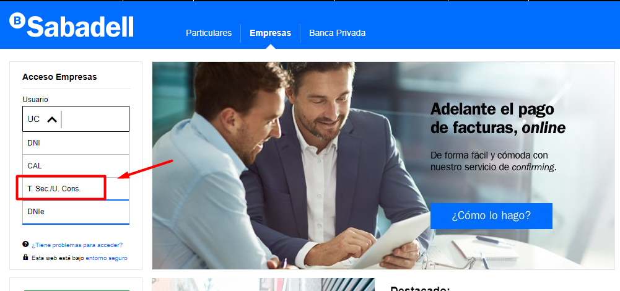

* Write the appropriate credentials and select ‘Entrar’

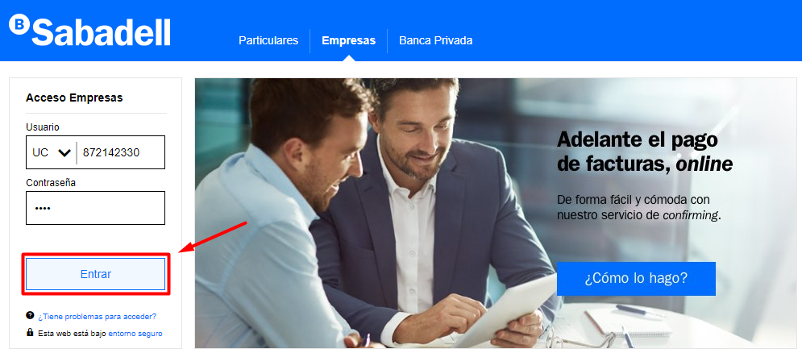

## Navigation to locate the download location

When we have already logged into the bank we will follow the following instructions:

* Select the ‘Operaciones TPV’ section that appears in the main menu under ‘Operativas destacadas’.

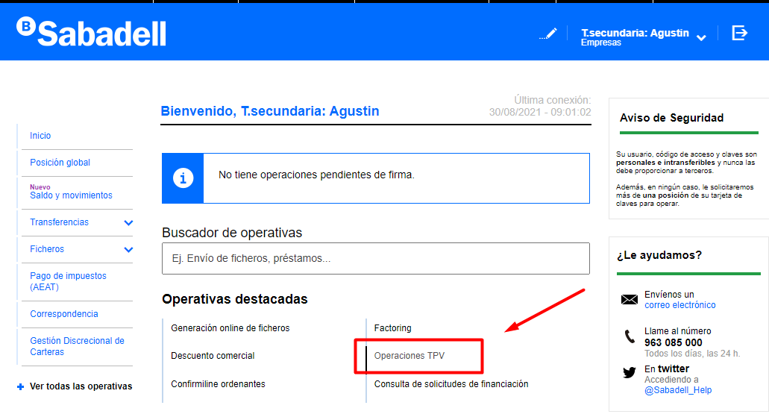

* From here we will proceed to download the corresponding files for the extraction of information by ‘ID Comercio’.

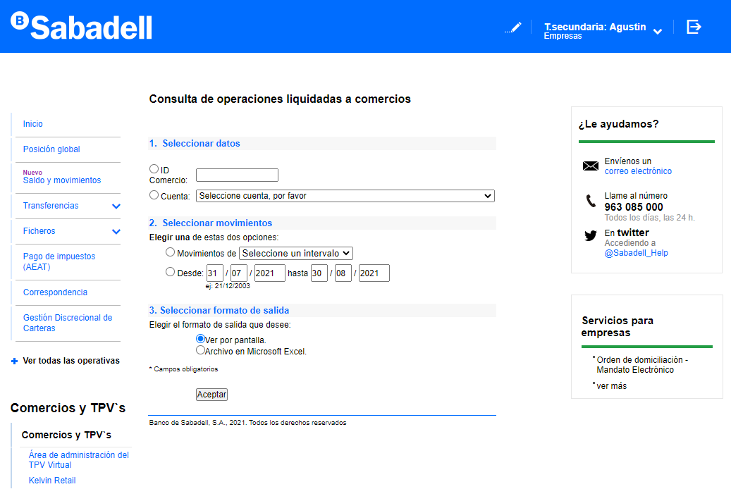

## Indicate query criteria by IdComercio

To download the POS Remittance files you have to do the following:

* Select ‘Id Comercio’ and add the corresponding field in the TextBox. This field will be obtained from the table ‘[lportal].[dbo].[_TesoraliaPOSFinancialIdComercio]'.
* Take the date of the last download day of the ‘ID Comercio’ from the table '[lportal]. [dbo]. [_TesoraliaPOSFinancialIdComercio]'.
  + When there is more than 1 day pending download, you will have to download day by day.
  + Example: from 27/08 to 30/08 no information was downloaded. You have to download a file of each day for each ‘ID Comercio’.
    - Download file of 27/08
    - Download file of 28/08
    - Download file of 29/08
    - Download file of 30/08
  + For each file downloaded (and inserted in database) must be updated the date of the ‘ID Comercio’
* Select the Radio Button of 'Archivo en Microsoft Excel’ to be able to download the file
* Click on ‘Aceptar’ to request the download of the file

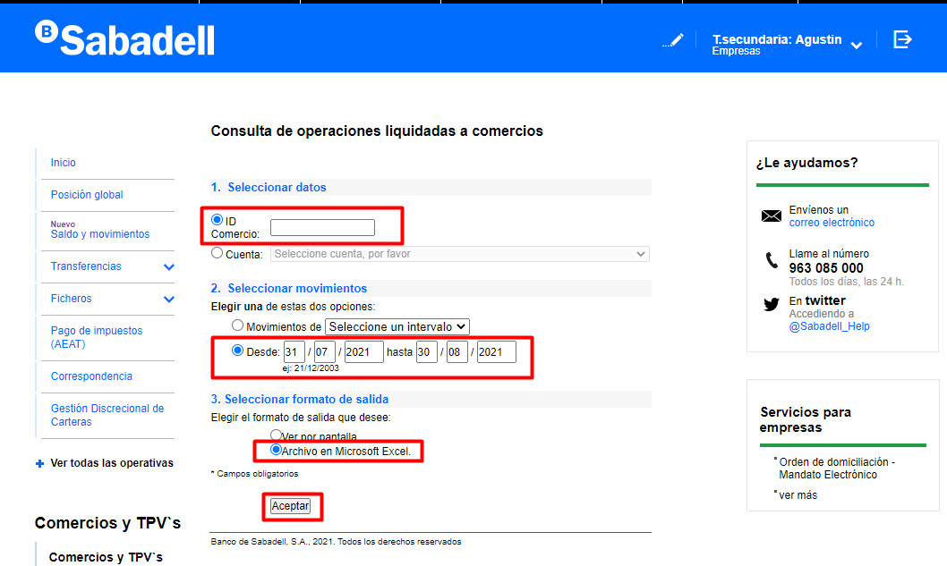

* In case that the ‘ID Comercio’ consulted has no movements, the following message will appear: " No existen movimientos en el periodo de fechas seleccionados ". When there are no movements, the ‘ID Comercio’ date of the table [lportal].[dbo].[_TesoraliaPOSFinancialIdComercio] must be updated with the date of the current day.

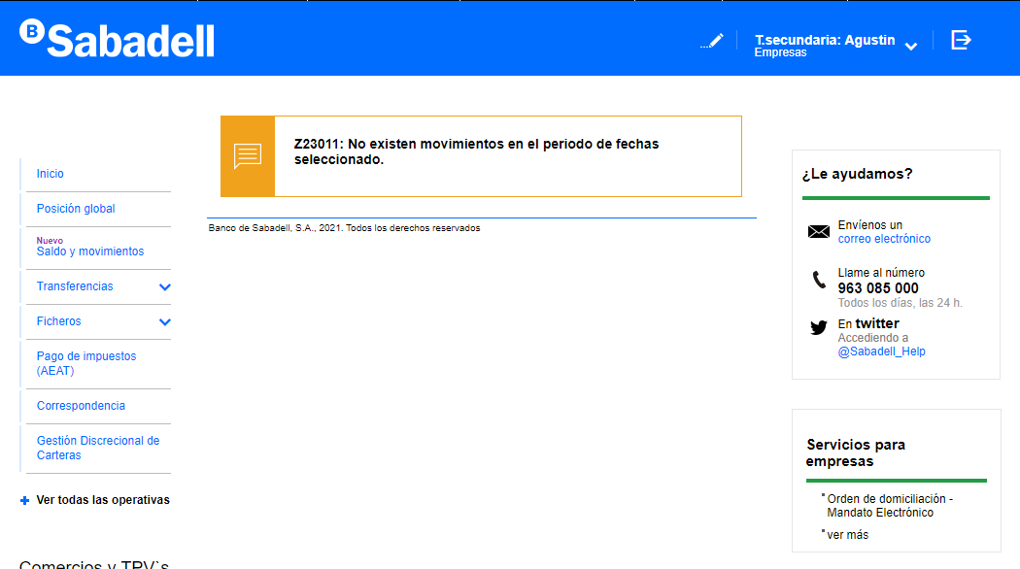

## Excel file download

### Renaming files

All downloaded Excels must be named with the following data:

* BusinessName
* Date and Time of Download

In addition, they must be stored for 14 days in a backup folder as evidence for future revisions in case of incidents.

Server IP -> 192.168.195.123

Path -> Z:\prod\files\remesas_tpv\

* In this path there must be a folder for each client that has POS Financial Collections
* Each client folder must contain a folder with the date in YYYYMMDD format that will store the Excel files downloaded each day
* The folders of the last 14 days must be kept and those that exceed that date will be deleted.

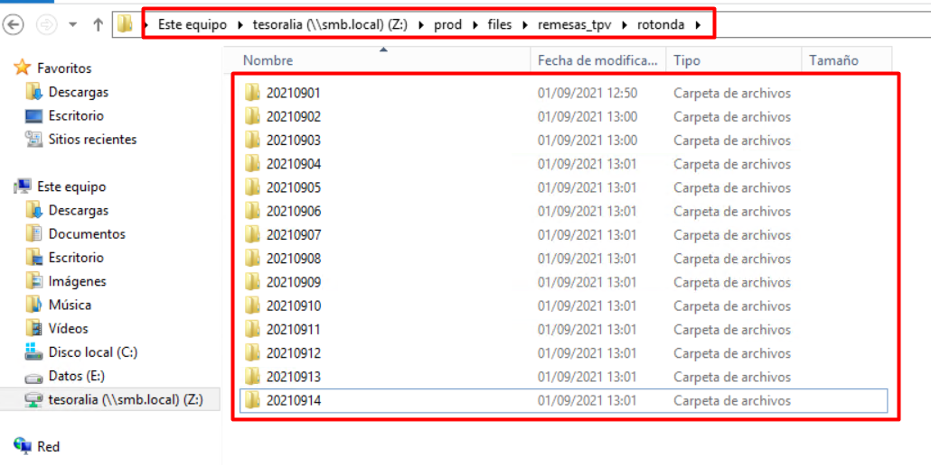

NOTE: This implementation is going to be carried out initially for ROTONDA, and we must verify that we can apply it to the AVIA download and to the generation of the extended Excel.

Example 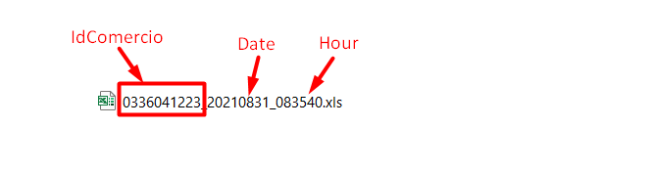



## Excel data extraction to insert into DB

There are cases in which the information does not come correctly in the downloaded Excel, so we will have to avoid the insertion in DB of these errors. In addition, in all these cases a specific record must be left that allows us to identify each Financial Collection to notify the client indicating ‘IDComercio’ and Date.

### Duplicate financial collections

The process must be able to identify Duplicate Remittances and set in the log the text: "Remesa duplicada" + ‘IdComercio’ + Download DateTime in case any are found.

Excel is attached with Duplicate financial collections 

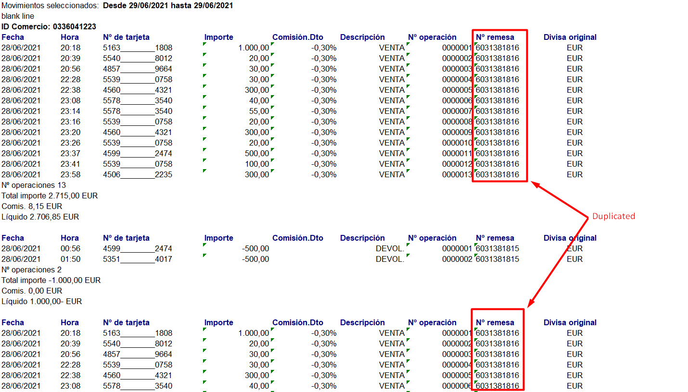

### Incomplete financial collections

The process must be able to identify incomplete Remittances and set in the log the text: "Remesa incompleta" + ‘IdComercio’ + Download DateTime in case any are found.

Partial information on incomplete financial collections should not be inserted into DB.

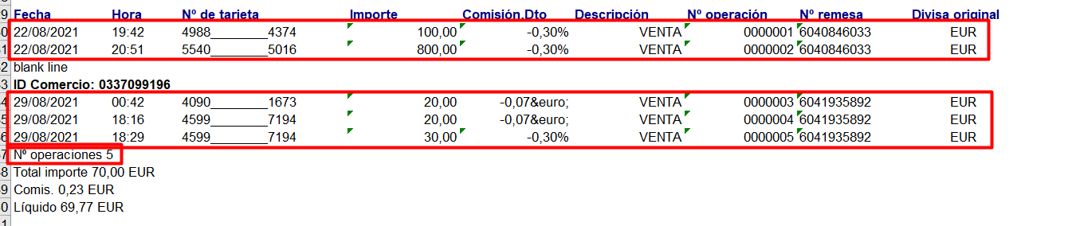

Excel is attached with Incomplete financial collections 

### Mixed financial collections

The process must be able to identify mixed financial collections and establish in the log the text: “Remesa mezclada” + ‘IdComercio’ + Download Datetime in case one is found.

Partial information from mixed financial collections should not be inserted into BD.

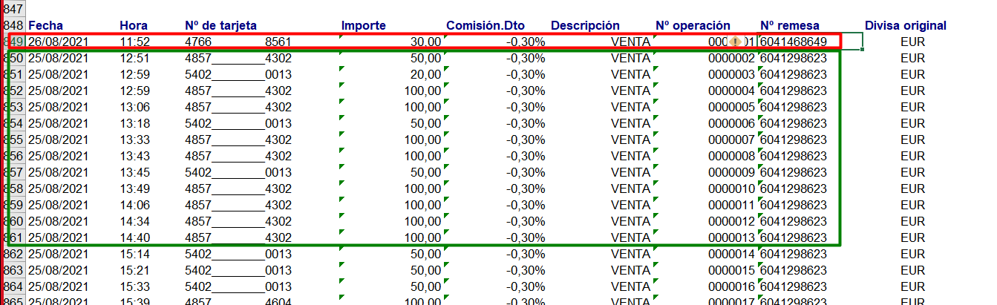

Excel is attached with Mixed financial collections 

## Data model

### Consult IdComercio information

The 'CommercialDid' will be obtained from the [lportal].[dbo].[_TesoraliaPOSFinancialIdComercio] along with the ‘FechaDescarga’

If the ‘FechaDescarga’ is less than the current day date minus one day, the process must download an Excel file each day.

After finishing the download, the process must set the ‘FechaDescarga’ with the value of the current day and time in the table [lportal].[dbo].[_TesoraliaPOSFinancialIdComercio] in the 'IdComercio' that corresponds to it.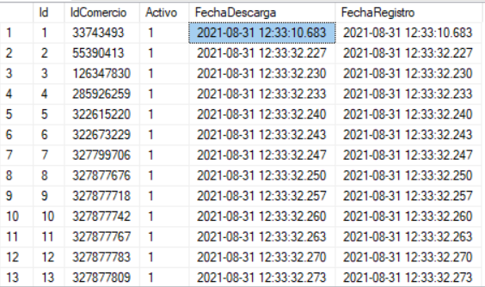

### Description of Financial collections

* A financial collection may contain one or more card payment movements. This information will be stored in the [lportal].[dbo].[_TesoraliaPOSFinancialCollections]
* The card payment movements of a financial collection are stored in the [lportal].[dbo].[_TesoraliaPOSFinancialCollectionsStatements] and both tables are linked through the 'POSFinancialCollectionId' field.

### Related tables

The following image shows the relationship between the tables involved in storing financial collections and their link to movements.

See attached image 

### Save information in DB

The following describes how to store the information obtained from the bank in the corresponding tables.

#### Primary Table _TesoraliaPOSFinancialCollections

On the table [lportal].[dbo].[_TesoraliaPOSFinancialCollections] the summary information for each financial collection is saved.

See attached document with the list of fields 

#### Foreign Table _TesoraliaPOSFinancialCollectionsStatements

On the table [lportal].[dbo].[_TesoraliaPOSFinancialCollectionsStatements] the detail of each financial collection is saved. Each of these records must be linked to the table [lportal].[dbo].[_TesoraliaPOSFinancialCollections] across the field ‘POSFinancialCollectionId’.

In order to identify financial collections that are unlinked in the linking process, the field 'POSFinancialCollectionId' should be reported by default with the value '-1'

See attached document with the list of fields 

## Link the tables

### Financial collection movements with each financial collection

To link financial collections movements (POSFinancialCollectionsStatements) to each financial collections (POSFinancialCollections) ->

* Make a query of the table [_TesoraliaPOSFinancialCollectionsStatements] to get the fields 'POSFinancialCollectionsStatementId' and 'ReferenceCollection' with the following conditions:
  + The 'POSFinancialCollectionId' field has to be equal to -1
  + Set 'Date' to be greater than today's date minus 20 days (this time lapse has been established from the tests carried out, but can be varied if it is detected that the bank improves or worsens the delivery of the information)
  + Query:
    - SELECT [POSFinancialCollectionsStatementId],

[ReferenceCollection]

FROM [lportal].[dbo].[_TesoraliaPOSFinancialCollectionsStatements]

WHERE

[POSFinancialCollectionId] = -1

AND

Date > GETDATE()-20

* With the 'ReferenceCollection' field extracted from the previous query we perform the following query:
  + Check that the value of the 'POSFinancialCollectionReference' field in the [_TesoraliaPOSFinancialCollections] table is equal to the extracted value
  + With this we obtain the value of 'POSFinancialCollectionId' from the table [_TesoraliaPOSFinancialCollections]
  + Query:
    - SELECT [POSFinancialCollectionId]

FROM [lportal].[dbo].[_TesoraliaPOSFinancialCollections]

WHERE [POSFinancialCollectionReference] = ‘ReferenceCollection’ from the previous query

* + Update the 'POSFinancialCollectionId' field of the [_TesoraliaPOSFinancialCollectionsStatements] table with the POSFinancialCollectionId' record, which is the primary key of [_TesoraliaPOSFinancialCollections].
  + Query:
    - UPDATE [lportal].[dbo].[_TesoraliaPOSFinancialCollectionsStatements]

SET [POSFinancialCollectionId] = ‘POSFinancialCollectionId’ from the previous query

WHERE [POSFinancialCollectionsStatementId] = ‘POSFinancialCollectionsStatementId’ from the first query

### Financial collections with Movements

To link the downloaded financial collections (POSFinancialCollections) with the general movement (TesoraliaStatements) you must follow the following steps ->

* Make a query to get the fields 'POSFinancialCollectionReference' and 'Base' linking the tables [_TesoraliaPOSFinancialCollections] and [_TesoraliaPOSFinancialCollectionsStatements] with the field 'POSFinancialCollectionId' and taking from 8 days ago (this time lapse has been established from the tests carried out, but can be varied if it is detected that the bank improves or worsens the delivery of the information).
  + Query:
    - SELECT DISTINCT c.POSFinancialCollectionReference, c.Base

FROM [lportal].[dbo].[_TesoraliaPOSFinancialCollections] c

INNER JOIN [lportal].[dbo].[_TesoraliaPOSFinancialCollectionsStatements] s

ON c.[POSFinancialCollectionId] = s.[POSFinancialCollectionId]

WHERE

Date > GETDATE()-8

* With these fields we make another query of the table [_TesoraliaStatements] to obtain the 'InitialId'
  + Set 'OperationalDate' to be greater than today's date minus 120 days
  + The 'amount' field must be equal to the 'base' field extracted in the previous query
  + The 'StatementDescription' field must contain the 'POSFinancialCollectionReference' also extracted in the previous query.
  + Query:
    - * SELECT [InitialId], [StatementDescription], [Amount]

FROM [_TesoraliaStatements] AS A

WHERE

(A.OperationalDate > GETDATE()-120)

AND

Amount =" + ’Base’ from the previous query.Replace(",", ".")

AND

StatementDescription LIKE ('% ‘POSFinancialCollectionReference’ from the previous query %')

* Finally, we update the table [_TesoraliaPOSFinancialCollections] according to the following indications:
  + Check that the value of the 'POSFinancialCollectionReference' field is equal to the one extracted in the first query.
  + Update with the result the field 'StatementId' with the value of the field 'InitialId' collected in the previous query.
    - In case no result has been collected, it will be equaled to -1.
  + Query:
    - UPDATE [_TesoraliaPOSFinancialCollections]

SET [StatementId] =' ‘InitialId’ from the previous query’

WHERE POSFinancialCollectionReference =

' ‘POSFinancialCollectionReference’ from the first query'